Image | 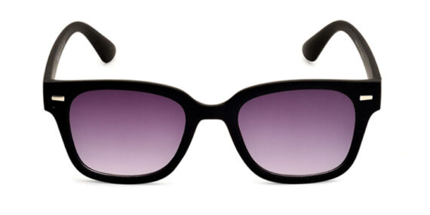
Brand | RAYBAN
Model Name | Brise
Price | RS 1800
PRODUCT DETAILS

